March 24, 2024
Sermon 27
Mark 8:1-21
Joseph Tucker

It’s a humbling thing to be prayed for, and it’s a reminder that we all need prayer, no matter who you are. I’m super thankful for you guys. It’s a joy to lead and be able to open the Word together.
Happy Palm Sunday, in case you didn’t know. Now you know. Next Sunday is Easter, which is when we get to remember and celebrate the resurrection of our Lord Jesus. If you don’t know anything about Palm Sunday, it marks the beginning of Passion Week, which is the last week of Jesus’ life, leading up to His arrest, and trial, and crucifixion. It’s a time when we get to remember Jesus’ triumphal entry into Jerusalem, where people are shouting, and screaming, and celebrating, and putting their coats on the ground, and waving palm branches, and Jesus is humbly riding into Jerusalem on a donkey. This is how the Gospel of Luke records that moment. It says,

As he was drawing near—already on the way down the Mount of Olives—the whole multitude of his disciples began to rejoice and praise God with a loud voice for all the mighty works that they had seen, ³⁸ saying, “Blessed is the King who comes in the name of the Lord! Peace in heaven and glory in the highest!” ³⁹ And some of the Pharisees in the crowd said to him, “Teacher, rebuke your disciples.” ⁴⁰ He answered, “I tell you, if these were silent, the very stones would cry out.”

I love that line because Jesus is saying His creation will cry out. Have you ever heard that song, “Ain’t no rock gonna cry in my place. As long as I’m alive, I’ll glorify His holy name.” So good. Man! The reason this is so awesome is that the Pharisees, once again, are coming at Jesus and trying to get Him to do things that and He’s like, “You guys have no clue.” They’re unhappy with Him. There are people proclaiming these messianic sayings about Jesus, and so they are super mad at Jesus. They’re mad at His disciples. His disciples are praising God because they’ve seen the mighty works that God has done, and they can’t shut up about it. They’ve seen Jesus do amazing things. They will finally get it, but we don’t see that tonight in our passage. They don’t get it yet.
So, I want us to focus in on this. I’m going to give you the main point of the passage up front. The main point is for you to remember. It’s for me to remember what God has done. We need to remember what God has done, we need to remember who Jesus is, and we need to remember that Jesus alone satisfies. As we continue our study through Mark tonight, we’re going to be in chapter 8 and we’re going to look at the first 21 verses. We’re going to go pretty quickly because there’s a lot in there.
There are three main sections. In the first section, we see the feeding of the 4000. In the second section, we see this interaction with the Pharisees, which is the last interaction that Jesus will have with them until in Jerusalem. In the last section, we see Jesus questioning His disciples, and rebuking them, and asking them a question that we all need to ask ourselves: Do you not yet understand? So, let’s pray and then we’ll read God’s Word together.
Father, we do come before your Word humbly, Lord, knowing that you said that if we are silent that your creation will cry out. Since we are the crown of your creation, we are created in your image, we were created by you and for you, to worship you, to exalt you, to lift up the Name above all names. I pray, right now, that you, Holy Spirit, would speak through your Word. Jesus, that you would be exalted, and that Father you would be glorified by the preaching of your Gospel, as we explore this amazing text tonight. It’s in Jesus’ name we pray, Amen.
Mark 8, beginning in verse 1. This is God’s Word.

In those days, when again a great crowd had gathered, and they had nothing to eat, he called his disciples to him and said to them, ² “I have compassion on the crowd, because they have been with me now three days and have nothing to eat. ³ And if I send them away hungry to their homes, they will faint on the way. And some of them have come from far away.”
⁴ And his disciples answered him, “How can one feed these people with bread here in this desolate place?” ⁵ And he asked them, “How many loaves do you have?” They said, “Seven.” ⁶ And he directed the crowd to sit down on the ground. And he took the seven loaves, and having given thanks, he broke them and gave them to his disciples to set before the people; and they set them before the crowd.
⁷ And they had a few small fish. And having blessed them, he said that these also should be set before them. ⁸ And they ate and were satisfied. And they took up the broken pieces left over, seven baskets full. ⁹ And there were about four thousand people. And he sent them away. ¹⁰ And immediately he got into the boat with his disciples and went to the district of Dalmanutha.
¹¹ The Pharisees came and began to argue with him, seeking from him a sign from heaven to test him. ¹² And he sighed deeply in his spirit and said, “Why does this generation seek a sign? Truly, I say to you, no sign will be given to this generation.” ¹³ And he left them, got into the boat again, and went to the other side.
¹⁴ Now they had forgotten to bring bread, and they had only one loaf with them in the boat. ¹⁵ And he cautioned them, saying, “Watch out; beware of the leaven of the Pharisees and the leaven of Herod.”
¹⁶ And they began discussing with one another the fact that they had no bread. ¹⁷ And Jesus, aware of this, said to them, “Why are you discussing the fact that you have no bread? Do you not yet perceive or understand? Are your hearts hardened? ¹⁸ Having eyes do you not see, and having ears do you not hear? And do you not remember? ¹⁹ When I broke the five loaves for the five thousand, how many baskets full of broken pieces did you take up?” They said to him, “Twelve.” ²⁰ “And the seven for the four thousand, how many baskets full of broken pieces did you take up?” And they said to him, “Seven.” ²¹ And he said to them, “Do you not yet understand?”

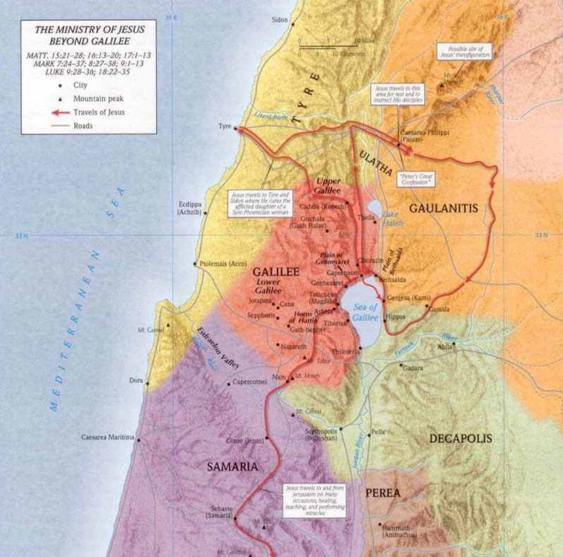
Now, you might be thinking to yourself, this sounds a lot like Mark 6, which we covered a few weeks ago, when Jesus fed 5000 men, which was really around 15000-20000 people. And you’re right, there’s a ton of similarities, but there are also a lot of differences. So, I’m not going to re-preach what Rob preached out of Mark 6. You can go back and listen to that if you want to. But some people who like to nitpick at the Bible, some critical scholars, believe that this is the same account, that the author just copied and pasted, and this only happened once. However, there are very clear differences in the text.
R. C. Sproul points out that in Mark 8 Jesus says, “They had been with me for 3 days,” which is totally different from the feeding of the 5000. There were 7 loaves in this one, not 5. And there were fewer baskets of leftovers. Also, while the feeding of the 5000 took place on the west coast of the Sea of Galilee, this feeding took place on the east coast of the Sea of Galilee, which is predominately a Gentile area.
So, as we’ve been seeing – you’re going to see a map on the screen – we’ve been looking at this map. Now, this is a little different one than the map Brody and Spencer put up there. This one has arrows, so you can see where Jesus went up to Tyre and Sidon, and then circled back around to the Decapolis. So, He’s on the eastern side of the Sea of Galilee at this feeding, which is a reminder that He’s saying that the Gospel is not only for the Jews; it’s for the Gentiles, as well as all nations.
We’re going to see that there is a large quantity of difference, as well, between the amount of people who were there. In this section, it’s actually 4000 people; men, women, and children. In the other account, they were only counting the men.
The most important distinction, so we know this is a totally different feeding, is because Jesus himself says it when He’s questioning His disciples. He says, “Hey, guys, how many baskets did you have left over when I did it this time? What about this time?” So, clearly there’s a difference.
Just as way of a reminder, too, this is not about food. It’s not about Jesus giving full bellies. The point was for them to see that God is in the flesh in front of them. The only one who could truly satisfy their soul is right in front of them. Where sin leads to death, Jesus leads to life, for Jew and Gentile. It doesn’t matter. Just as Pastor Rob said, and I quote, “Jesus didn’t come to give bread, but to be bread. It’s not seeing the miracle that’s important; it’s submitting to the miracle-Worker.” I love that line. It’s submitting to Jesus, not what He can do for you, or has done for you. Those who look to Jesus, who partake in what Jesus offers, trust the Bread of Life, the all-powerful Bread of Life, who multiplies the physical bread to feed bellies temporarily, in order to point to a much greater reality of Him satisfying our hungry souls.
So, what I want us to do is look at, in the first three verses, some characteristics of Christ. If you look at these, you’ll see first there’s a problem. There’s a problem. There’s nothing to eat in a desolate place that they’re in, and we see that Jesus has compassion on the crowd. This reminds us, and it should lead us, as Christ’s Church, to be more compassionate to all people, just like our Lord Jesus was compassionate. I know that’s something I struggle with and I often need help with. Asking the Lord, “Help me to show compassion, just as you’re compassionate towards me.”
What else do we learn about Jesus in these verses? We see a few things, right? We see that Jesus knows their lack. He paid attention to the small things. He knew that they were without food. They had nothing to eat. He not only knew but He cares. He gives food to them so that they don’t faint. He cares about that. He knew that they were going to depart from Him, they were going to walk home. He didn’t want them to faint. So, He cares for them. And – I love this part – it says that He knew how far they had come to be with Him.
Listen to this Red Oak. Listen carefully. Jesus knows your lack. He knows your need. He knows and He cares. And He not only knows, and He not only cares, but He also knows where you’ve been, and where you are coming from, and where you’re going. He knows your past, your present, and your future. We can’t get away from His knowledge. He knows all.
In verse 4, we see the disciples’ question.

“How can one feed these people with bread here in this desolate place?”

Have they forgotten His miraculous provision in the past? They forget about what God has done. Have they forgotten about what God did in the wilderness with the Israelites? Have they forgotten about the manna, in a desolate place, where God fed all of Israel, day, after day, after day. They forgot Jesus doing the exact same thing with the bread and the fish.
This week in my reading, I read this guy named Pastor Nelson. He said this,
Manna was God’s provision of deliverance from starvation. Jesus is God’s provision of deliverance from damnation. Just as the manna had to be consumed to preserve the lives of the Israelites, so Jesus has to be consumed (fully received by faith) for salvation to be received.
So, the disciples didn’t remember or believe that Jesus could do it again. They didn’t trust Him in the moment. They only focused on where they were – desolate place – not Who they were with. That smacked me upside the face as I was studying this. I thought, “How often is that true of me? Am I focusing on my present circumstances, my present situation, my present environment, and what I lack, rather than Who is with me? It can be easy for us to do that. We think about and focus on material things, things that we don’t have, people we’re not with, rather than focusing on Who is always with us. Jesus has to remind them in the next few verses of who He is.
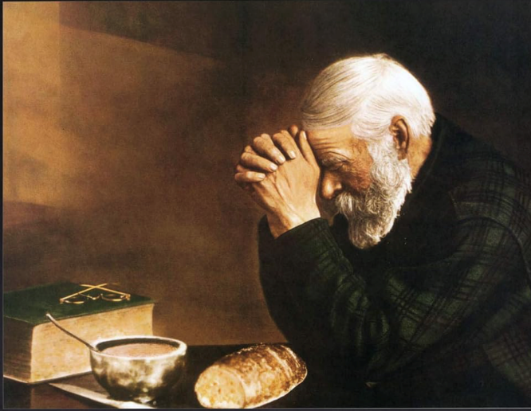
And He’s setting an example for us, as well. This is where we get the idea of saying grace, or giving thanks, before a meal. As I read this, I couldn’t help but think of this picture, of this painting. Maybe some of you have seen it before. My parents had it hanging up above our dining room table when we were growing up. It’s just a simple painting called “Grace.” The dude is praying before his meal with some food. You think that’s a Bible, but it’s actually a dictionary. Fun facts.
But Jesus directs the crowd. When His disciples have no clue what to do, Jesus takes charge. Right? He’s like, “Tell these people to sit down.” He just takes over. He directs the crowd to sit down and He’s going to give them enough for everybody to eat. They’re probably wondering, “Why is He praying when there’s not enough food?” It would be like He said, “Everybody sit down. We’re going to have a picnic.” And everybody is like, “I don’t see any baskets. I don’t see a lot of food.” So, Jesus says,

“How many loaves do you have?”

And the disciples are like, “Seven. Not enough, bro. Not enough. Look around.” So, they bring Him the seven loaves, and Jesus prays, and He gives thanks – check this out – before the distribution of the food. He looks to the Father and gives thanks before the food is multiplied. So, Jesus broke the bread and gave it to the disciples. This is foreshadowing for the Last Supper that’s just around the corner. Why do we do the Lord’s Supper? To remember Him. To remember who He is. To remember what He’s done. So, His disciples distribute the broken bread that Jesus provides. And Jesus did not doubt, but believed. He looked to the Father. Just like last week when He wanted the deaf and mute guy to know that this power comes from on high. He gives thanks. Jesus didn’t have to pray beforehand. He could have just done it. But He gives thanks to the Father and then He acts.
Are you trusting in God’s provision even when you can’t see it? Even when you don’t know where it’s going to come from, are you trusting in His provision? Or are you focusing on your own lack? Maybe you’re trying to solve the problem yourself, without going to Him in prayer.
The last part of verse 6 could be translated like this: Jesus kept breaking the bread, and kept giving it to His disciples, who kept giving it to the people. In my mind, I thought that Jesus prayed and then it was like *boom* and there was bread for all 4000 people. Everybody had bread in front of them spontaneously. But here, it says they had to keep going back to get the bread and giving it to the people. Which is what we should do. We should keep going back to Jesus, always, because that’s where we get our supply.
Then, Jesus blesses the small fish, and He gives it to the people, and they ate, and this is my favorite line,

…and they were satisfied.

And they were satisfied. All people ate. All people who were there were satisfied. That Greek word for satisfied is chortazō. I probably completely butchered that word; you can ask Zach later if I said that wrong. But it means ‘to fill up,’ ‘to satisfy,’ ‘to fulfill.’ In John 6:26, it says,

“Truly, truly, I say to you, you are seeking me, not because you saw signs, but because you ate your fill of the loaves.”

Because you were satisfied. Because your belly was full.
I’ll be the first one to admit, I absolutely love food. I am so thankful that God did not make us like cars. You don’t hear your car making any noises when you put gas in it. But when we eat some good food, it’s like an involuntary reaction. We’re like “Yumm-m-m-m! That’s delicious!” Because you have tastebuds, and God didn’t have to give you tastebuds, but He gave you tastebuds, because He’s good. So, we should thank Him for that, and enjoy the gift of food.
As I was studying this, I was wondering to myself, “I wonder how delicious this meal was?” How good was this food that Jesus made. You might think, “This is not a five-course meal,” or whatever. Who cares? They’re in a desolate place, there’s nothing to eat, they ain’t around any cafes, or tiendas, or anything, right? There’s nothing to eat and they are hungry, so hungry that if they walk away they’re going to faint. So, they’re about to get bread, and they’re about to get fish, and I’m wondering, “What did that taste like?” It had to be delicious. Everybody was like, “You saved the best for last.” Jesus made the best wine; this had to be the best bread. It had to be the best bread; it had to be the best fish. Did they use Old Bay seasoning? I don’t know. I’m not sure. We’re not told. But you know it was delicious, right? And, I don’t know about you, but I always thought – in my mind I had a picture that everybody gets a filet of fish, or a fish filet, or whatever. Not like McDonald’s. But I imagined it like you would get this big fish filet. Apparently, that’s not what was happening in this scene. That’s not how they ate fish anyway. It’s not like when we go to the grocery store, and we walk through the fish market. That’s not it. There’s going to be a picture on the screen.
In 2018, I went to Myanmar, Burma, on a mission trip, and this was one of our guides. His name was John Biak. We went by this lake and we walked through a fish market. It was their grocery store, right on the lake, right in the middle of nowhere, and he bought this fish. They make it, and what you see is what you eat. You get the whole thing. You see the tail, you see the eyes, and you see everything as you’re eating.
So, it’s not like that in this passage, and how we know that is because of the Greek. The word for fish is different in Mark 6 than in Mark 8. R. C. Sproul, once again, said,
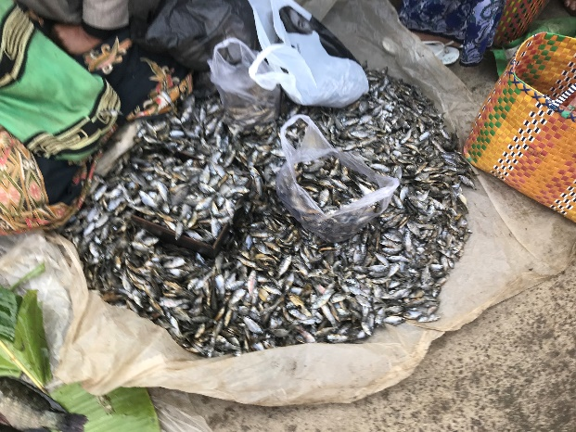
A generic Greek word for “fish” was used in Mark 6, whereas in Mark 8 the word translated as “fish” specifically refers to sardines.
Yum, yeah. So, it probably looked like this. That’s another picture in the same fish market I was walking through, and it smelled wonderful. And that’s probably what it looked like when Jesus multiplies the fish. Everybody was getting some sardines, right?
How Jesus prepared this, we don’t know. Maybe it was just as is, I don’t know. But what we do know is they all ate and were satisfied. They got protein, they got vitamins, they got carbs, they got what they needed. The Creator gave their bodies what they needed, and it was pointing to Him. It was all pointing to Him. It was all about Him. He wanted them to see that He alone satisfies. That’s what Jesus is trying to get the people to see.
In Psalm 107:9, it says,

For he satisfies the longing soul,
and the hungry soul he fills with good things.
Psalm 145:16 says,

You open your hand;
you satisfy the desire of every living thing.

And the prophet, Joel, in Joel 2:26, says this,

You shall eat in plenty and be satisfied,
and praise the name of the Lord your God,
who has dealt wondrously with you.
And my people shall never again be put to shame.

Only Jesus satisfies. The world will say a lot of things satisfy. They will try to point you in different directions and say, “This satisfies…this satisfies…Get in that relationship…Chase money…Chase success…Chase fame….whatever,” but only Jesus satisfies, and only Jesus satisfies with leftovers. There are a lot of leftovers. It says in Mark 8:8 that they had 7 basketsful of leftovers. You might be like, “Well, that’s not as many leftovers as the last time, where He fed the 5000.” Well, hold on, because that’s not the only word in Greek that’s different, like ‘fish.’ In Mark 6, the Greek word for basket is like a little reed basket. In Mark 8, in this passage, think ‘laundry basket.’ Think of a basket big enough for a grown man to fit into. In Acts 9:25, it says,

…but his disciples took him (Paul) by night and let him down through an opening in the wall, lowering him in a basket.

I don’t know how big your laundry hamper is, but my kids can fit in ours. Can you imagine 7 laundry hampers full of leftovers? This is unbelievable.
In verse 10, we see this transition to an encounter with the Pharisees. And verse 11 is not a fun encounter. It’s not cordial. It says,

The Pharisees came and began to argue with him, seeking from him a sign from heaven to test him.

R. C. Sproul said this,
The Pharisees weren’t looking for a polite discussion or debate. They were hostile toward Him. This hostility manifested itself in a demand for a sign, proof of His divinity.
Jesus had already given ample signs for the Pharisees, but they refused to trust in Him as the Messiah. Their problem was unbelief. They had a hard heart and they were corrupt. They weren’t humbly seeking Jesus here. They were not drawing near to Him to ask genuine questions. They were trying to prove something. They wanted Him to prove himself. And they did the same thing when He was hanging on the cross. In Matthew 27, it records,

And those who passed by derided him, wagging their heads ⁴⁰ and saying, “You who would destroy the temple and rebuild it in three days, save yourself! If you are the Son of God, come down from the cross.” ⁴¹ So also the chief priests, with the scribes and elders, mocked him, saying, ⁴² “He saved others; he cannot save himself. He is the King of Israel; let him come down now from the cross, and we will believe in him.”

Same thing. Warren Wiersbe said this,
Their desire for a sign from heaven was but another evidence of their unbelief, for faith does not ask for signs. True faith takes God at His Word and is satisfied with the inward witness of the Spirit.
The Pharisees were seeking to test Jesus much like Satan in the wilderness.

“if you are truly the Son of God, do this…prove it!”

Look at Mark 8:12 to see how Jesus responds. *Sigh* It says, “In His spirit,” so He probably didn’t sigh out loud. I don’t know. I would have liked to have been there. But He’s fed up.

And he sighed deeply in his spirit and said, “Why does this generation seek a sign? Truly, I say to you, no sign will be given to this generation.”

I don’t know about you, but in my conversations with people all around the world, I have had people say, “Well, if God would do this, I’d believe.” or, “If He would just give me this…If He would just show me this…If He would just give me a sign.” Right? You just want to sigh, and say, “Here. Read this. Look at this.” A sign – they’re asking for a sign, when Jesus had fulfilled all of their Scriptures, all the messianic prophecies in their Bible. He had fulfilled them all. How about Him backing up all of His teachings with demonstrations of divine power? He healed the leper. He had authority over the demonic. He gave sight to the blind and made deaf ears hear. He immediately caused muscles, tendons, and tissue, and bone to grow instantaneously for the paralytic man, to jump up and run out. Remember the Pharisees who were there? In the Temple, they saw that man’s hand grow in front of their eyes. As the old comedian, Bill Engvall, said, “Here’s your sign.” The Pharisees didn’t believe the Word of God. They didn’t believe the miracles. They didn’t believe the Son of God, the Word made flesh, in front of their eyes.
So, He sighs. He sighed last week, too. Remember when He was in front of the deaf and mute man? He sighs. It’s a deep sigh of anguish, of sin ravaging His creation, and here it’s a sigh of a groan. It hurts His heart – their unbelief, their hardness of heart.
In John 6, Jesus says this,

Do not work for the food that perishes, but for the food that endures to eternal life, which the Son of Man will give to you. For on him God the Father has set his seal.” ²⁸ Then they said to him, “What must we do, to be doing the works of God?” ²⁹ Jesus answered them, “This is the work of God, that you believe in him whom he has sent.” ³⁰ So they said to him, “Then what sign do you do, that we may see and believe you? What work do you perform? ³¹ Our fathers ate the manna in the wilderness; as it is written, ‘He gave them bread from heaven to eat.’” ³² Jesus then said to them, “Truly, truly, I say to you, it was not Moses who gave you the bread from heaven, but my Father gives you the true bread from heaven. ³³ For the bread of God is he who comes down from heaven and gives life to the world.” ³⁴ They said to him, “Sir, give us this bread always.”
³⁵ Jesus said to them, “I am the bread of life; whoever comes to me shall not hunger, and whoever believes in me shall never thirst. ³⁶ But I said to you that you have seen me and yet do not believe. ³⁷ All that the Father gives me will come to me, and whoever comes to me I will never cast out. ³⁸ For I have come down from heaven, not to do my own will but the will of him who sent me. ³⁹ And this is the will of him who sent me, that I should lose nothing of all that he has given me, but raise it up on the last day. ⁴⁰ For this is the will of my Father, that everyone who looks on the Son and believes in him should have eternal life, and I will raise him up on the last day.”

This is God’s Word. And as I read that, as I was studying this passage, I was wondering, does Jesus still sigh? Does Jesus sigh at our unbelief sometimes? We aren’t the Pharisees. We aren’t the Apostles. We have all of the Old Testament, all of the New Testament. We have over 2000 years of Church history, and yet people still dismiss all of the signs, all of the evidence. So, the call for us today is to not miss what God has already done. Remember what He’s already done. Remember who He is, who He said He was. And He backs it up every single time. But sadly, we’re forgetful people. As the disciples so easily demonstrate in the next few verses. Look at Mark 8:14-16. It says,

¹⁴ Now they had forgotten to bring bread, and they had only one loaf with them in the boat. ¹⁵ And he cautioned them, saying, “Watch out; beware of the leaven…”

They were still questioning about lunch. Can you tell that these are teenage boys in these few verses?
They are constantly hungry. Yesterday, we left with Red Oak Youth for Atlanta at 2:00pm, just a few hours after lunch, and a few of the boys brought backpacks. I said, “You don’t need a backpack. You can’t even go into the stadium with that. What are you doing?” And they answered, “It’s my snacks.” I said, “We’re stopping at Chick-fil-A in about two hours,” and they were like, “I’m going to get hungry.”
These are disciples. They’re always hungry. They’re constantly hungry. They had just eaten and it said they were satisfied, and now they’re looking for a snack. But they didn’t prepare very well. Why? Because they forgot the baskets. They left the leftovers. I mean I’m guilty of that, sadly. Have you ever gone to a restaurant, and you had a to-go box, and you left it on the table? I hate when that happens. But it’s relatable. I don’t like it, but I can relate with the disciples here.
They seemingly also forgot the miracle, and they just forgot the Miracle Worker in front of them. And I can’t throw them under the bus because I, too often, do this. I forget the Gospel. I forget Jesus. I forget what He can do and what He’s already done. Because sometimes I’m more prone to focus on the physical and the temporary than on the eternal. I all too often neglect the kingdom of God. I’m not thinking about things that are eternal, and Jesus warns them here. He warns them to stay on their guard.
Leaven, in this passage, symbolizes sin or evil. The Life Application Bible says,
The Herodians were known for their skepticism, materialism, and political opportunism. The Pharisees were self-righteous, maintaining a form of religiousness without inner strength and spiritual insight….so the evil teachings and hypocrisy of the religious and political leaders could permeate and contaminate.
So, Jesus is using leaven as a metaphor for sin, or false teaching, corruption. A small little bit of it can work through the whole batch of dough. So, Jesus is warning His disciples to watch out. Because they, and us today, are just as susceptible to have hard hearts. We’re just as easily swayed to focus on everything but the kingdom of God. We’re all too easily focused on what we’re going to eat after church rather than on the spiritual bread that’s more important. Once again, Jesus is saying, “The bread’s not the point, y’all.” He’s warning them of spiritual dangers.
Verse 16 is ironic in many ways. The disciples are so focused on temporary food that they’re missing the point of the feedings. They’re missing the point of the warning, in fact. It’s ironic because they’d already forgotten the provision of God. They’d already forgotten who is with them in the boat. Jesus is aware of this and He responds in verse 17, and says, “Why are you discussing the fact that you don’t have a snack?”

“Do you not yet perceive or understand? Are your hearts hardened?”

Translation – “I’m the only Bread you should be concerned about!”
Even miraculous bread from Heaven, even manna, even multiplied bread from Jesus himself, has to be digested, and the physical body gets hungry again. The physical body that we’ve been feeding our whole life will die. But if you feast on Jesus, the Bread of Life, you will live forever. Jesus wanted His disciples to realize this – that “man does not live by bread alone, but by every word that comes from the mouth of God.”
So, He asks some very stinging questions to His disciples. This had to be a humbling boat ride. “Why are you talking about bread still? Why do you not understand? Are your hearts hardened?” He’s already warned them, “Are your hearts like the Pharisees’? Are you leaning that way?”
Having eyes do you not see, and having ears do you not hear? And do you not remember?

Then, He gives them just a little illustration. About what? What He’s already done, in the past, both feedings. “Remember that – remember the 5000? Remember the 4000? Do you still not understand?” The disciples were slow to comprehend who Jesus is. They were slow to see – this is the Messiah and He’s on a messianic mission from the Father. But all hope is not lost for them because of the little word ‘yet.’ It says, “Yet.” They didn’t see yet. They didn’t believe or understand yet. But they will.
So, as we close, I want us to ask some questions personally. Do you see yourself in this passage? Are you more prone to be like a Pharisee, testing Jesus and demanding a sign? Or are you like a disciple who has forgotten who Jesus is? Forgotten what God has already done for you? Jesus proved who He was and who He is, time and time again. But we often complain, or forget, or we’re afraid, or we demand a sign.
So, a few questions: Will you plead for eyes to see and then look at the Book? Look at the Scriptures. Will you ask God for ears to hear, to truly hear, to comprehend His Word, and then truly listen. Listen to Him teach you through the Word. Do you believe? Do you really, truly believe in your heart of hearts that Jesus alone satisfies; that nothing else in this world can satisfy you? That anything you’re tempted to run to is going to leave you empty and hungry? Will you remember what He’s done for you? Will you remember who He is? That the Bread of Life satisfies always? Will you remember the very beginning of this passage? That Jesus has great compassion? Will you remember His lovingkindness? Will you remember His infinite knowledge?
Remembering is key for believers. It’s key. That’s why we gather. That’s why church is important – so we won’t forget, so that we will remember the Gospel. That’s why we read the Scriptures aloud together. That’s why we sing songs aloud together – to remember, to point ourselves, to point each other, to Jesus. And that’s why we do the Lord’s supper once a month. To remember. That’s why we practice spiritual disciplines on a consistent basis. This is why God gave us His Word. This is why God gave us examples in history. To remember, to remember who He is, to remember what He’s done.
One pastor said,
Remembering what we have seen our Lord do in the past should help us trust Him in the present.
Remember what we have seen Him do in the past should help us trust Him in the present. Let’s close by reading Psalm 103. It says,

Bless the Lord, O my soul,
and all that is within me,
bless his holy name!
² Bless the Lord, O my soul,
and forget not all his benefits,

Forget not all His benefits.
³ who forgives all your iniquity,
who heals all your diseases,
⁴ who redeems your life from the pit,
who crowns you with steadfast love and mercy,
⁵ who satisfies you with good
so that your youth is renewed like the eagle's.

Father, I pray that we would not forget who you are and what you’ve done. Lord Jesus, would you help us to see, help us to hear, help us to know deep down that you truly satisfy, that there is no one and nothing else on this Earth that satisfies? We were created by you and for you. Help us to readily run to you every day when we wake up and remember what you’ve done for us; remember how faithful you have been; remember how trustworthy you are; and remember this glorious, good news of the Gospel – and that we, like your disciples on Palm Sunday would sing, “Hosanna! Praise be to the only and only Jesus, our great King! Our great God!” It’s in your name we pray, Amen.

